Coal LAB 9
CODE 1

org 100h
jmp start
nums dw 1, 6, 64, 100, 1024, 0, 4096, 96
pow_count dw 0
exp_sum dw 0

is_pow2:
mov bx, ax
and bx, bx
jz not_power
dec bx
and bx, ax
jnz not_power
stc
ret
not_power:
clc
ret
bitpos:
mov cx, ax
mov bx, 0
check_bit:
cmp cx, 1
je position_found
shr cx, 1
inc bx
jmp check_bit

position_found:
mov ax, bx
ret
classify:
call is_pow2
jc is_power
clc
ret

is_power:
call bitpos
stc
ret
start:
mov si, nums
mov di, 8
next_num:
mov ax, [si]
call classify
jc power_found
jmp next_item
power_found:
inc word [pow_count]
add [exp_sum], ax
next_item:
add si, 2
dec di
jnz next_num

mov ax, 4C00h
int 21h

AFD
Power count
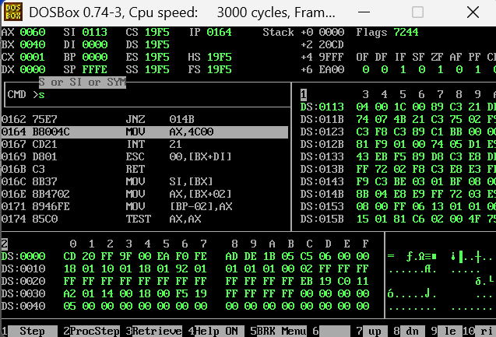
Exp sum
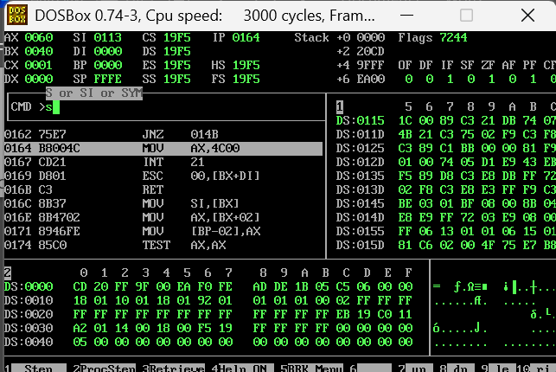

CODE 2
org 100h
jmp start

arr dw 9, -3, 14, 0, -8, 5, 22, -1
swaps dw 0

swap_if_greater:
push ax
push bx

mov ax, [bx]
cmp ax, [bx+2]
jg swap

clc
pop bx
pop ax
ret

swap:
push word [bx]
push word [bx+2]
pop word [bx]
pop word [bx+2]

stc
pop bx
pop ax
ret

start:
mov cx, 7

pass_loop:
mov bx, arr
mov dx, 7

compare_loop:
call swap_if_greater
jnc no_swap
inc word [swaps]

no_swap:
add bx, 2
dec dx
jnz compare_loop

loop pass_loop

mov ax, 4C00h
int 21h

AFD
Arr sorted
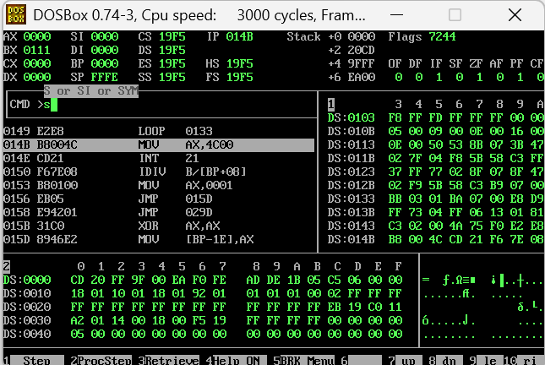

CODE 3
org 100h
jmp start

num1 dw 1170h, 0001h
num2 dw 0FBD0h, 0001h
num3 dw 0D090h, 0003h

total_lo dw 0
total_hi dw 0

limit_lo dw 1A80h
limit_hi dw 0006h

over db 0

half_lo dw 0
half_hi dw 0

add32:
push bp
mov bp, sp

mov ax, [bp+10]
add ax, [bp+6]

mov dx, [bp+8]
adc dx, [bp+4]

pop bp
ret 8

start:
push word [total_lo]
push word [total_hi]
push word [num1]
push word [num1+2]
call add32

mov [total_lo], ax
mov [total_hi], dx

push word [total_lo]
push word [total_hi]
push word [num2]
push word [num2+2]
call add32

mov [total_lo], ax
mov [total_hi], dx

push word [total_lo]
push word [total_hi]
push word [num3]
push word [num3+2]
call add32

mov [total_lo], ax
mov [total_hi], dx

mov byte [over], 0

mov ax, [total_hi]
cmp ax, [limit_hi]
ja set_over
jb divide_total

mov ax, [total_lo]
cmp ax, [limit_lo]
ja set_over
jmp divide_total

set_over:
mov byte [over], 1

divide_total:
mov ax, [total_lo]
mov dx, [total_hi]

shr dx, 1
rcr ax, 1

mov [half_lo], ax
mov [half_hi], dx

mov ax, 4C00h
int 21h

AFD
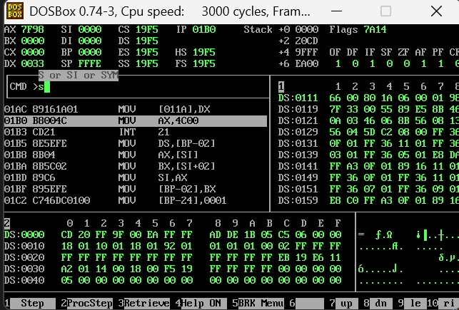

CODE 4
org 100h
jmp start

bitmap dw 0
booked_count dw 0
rejected dw 0

requests dw 1,3, 1,7, 1,3, 1,12, 2,7, 2,9, 1,15

make_mask:
push cx
mov cx, ax
mov ax, 1
shl ax, cl
pop cx
ret

is_booked:
push bp
mov bp, sp
push bx

mov ax, [bp+4]
call make_mask

mov bx, [bitmap]
test bx, ax
jz not_booked

stc
pop bx
pop bp
ret 2

not_booked:
clc
pop bx
pop bp
ret 2

book_seat:
push bp
mov bp, sp
push bx

mov ax, [bp+4]
push ax
call is_booked
jc book_reject

mov ax, [bp+4]
call make_mask
or [bitmap], ax
inc word [booked_count]

clc
pop bx
pop bp
ret 2

book_reject:
stc
pop bx
pop bp
ret 2

cancel_seat:
push bp
mov bp, sp
push bx

mov ax, [bp+4]
push ax
call is_booked
jnc cancel_reject

mov ax, [bp+4]
call make_mask
not ax
and [bitmap], ax
dec word [booked_count]

clc
pop bx
pop bp
ret 2

cancel_reject:
stc
pop bx
pop bp
ret 2

start:
mov si, requests
mov cx, 7

request_loop:
mov ax, [si]
cmp ax, 1
je do_book

push word [si+2]
call cancel_seat
jmp check_result

do_book:
push word [si+2]
call book_seat

check_result:
jnc request_done
inc word [rejected]

request_done:
add si, 4
loop request_loop

mov ax, 4C00h
int 21h

AFD


